
Allergy Action Plan
THIS CHILD HAS THE FOLLOWING ALLERGIES:













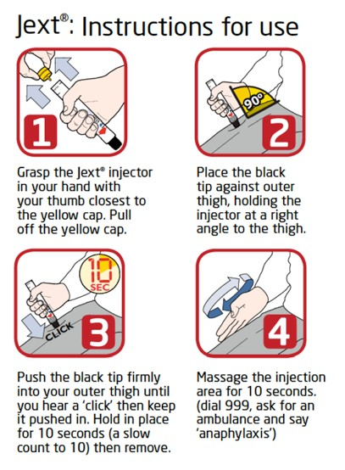

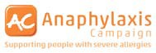
Mild-moderate allergic reaction:
Name:

DOB:

Swollen lips, face or eyes

- Itchy / tingling mouth
- Hives or itchy skin rash
ACTION:
- Abdominal pain or vomiting
- Sudden change in behaviour

  - Stay with the child, call for help if necessary
  - Give antihistamine:

Photo
  - Contact parent/carer

(if vomited, can repeat dose)

Watch for signs of ANAPHYLAXIS

(life-threatening allergic reaction):
Emergency contact details:
1)
!

2)
!
Child’s Weight:

AIRWAY: Persistent cough, hoarse voice,
difficulty swallowing, swollen tongue
BREATHING: Difficult or noisy breathing,

wheeze or persistent cough
CONSCIOUSNESS: Persistent dizziness / Pale or floppy

Suddenly sleepy, collapse, unconscious
Kg
If ANY ONE of these signs are present:
    - Lie child flat. If breathing is difficult, allow to sit

Give Jext®
    - Dial 999 for an ambulance* and say ANAPHYLAXIS (“ANA-FIL-AX-IS”)

If in doubt, give Jext®

After giving Jext:

Stay with child, contact parent/carer
- Commence CPR if there are no signs of life
- If no improvement after 5 minutes, give a further Jext® or alternative adrenaline autoinjector device, if available
*You can dial 999 from any phone, even if there is no credit left on a mobile.
Medical observation in hospital is recommended after anaphylaxis.

Additional instructions:

Keep your Jext device(s) at room temperature, do not refrigerate.
For more information and to register for a free reminder alert service, go to www.jext.co.uk

Parent/ Guardian’s Signature

Date:-_______________________________________
Produced in conjunction with:

!The British Society for Allergy & Clinical Immunology
www. b s a c i . o r g Approved Oct 2013

