
ALLERGY ACTION PLA

This child has the following allergies:
N

Name:

DOB:


Mild/moderate reaction:
- Swollen lips, face or eyes
- Itchy/tingling mouth
- Hives or itchy skin rash
- Abdominal pain or vomiting
- Sudden change in behaviour
Action to take:
- Stay with the child, call for help if necessary
- Locate adrenaline autoinjector(s)
- Give antihistamine:
(If vomited,
can repeat dose)
- Phone parent/emergency contact

Emergency contact details:
AFTER GIVING ADRENALINE:
- Stay with child until ambulance arrives, do NOT stand child up
- Commence CPR if there are no signs of life
- Phone parent/emergency contact
- If no improvement after 5 minutes, give a further adrenaline dose using a second autoinjectilable device, if available.
You can dial 999 from any phone, even if there is no credit left on a mobile. Medical observation in hospital is recommended after anaphylaxis.
mg)
Use Adrenaline autoinjector without delay (eg. Emerade®) (Dose:
Dial 999 for ambulance and say ANAPHYLAXIS (“ANA-FIL-AX-IS”)
*** IF IN DOUBT, GIVE ADRENALINE ***
2
3
Watch for signs of ANAPHYLAXIS
(life-threatening allergic reaction)
Anaphylaxis may occur without skin symptoms: ALWAYS consider anaphylaxis in someone with known food allergy who has SUDDEN BREATHING DIFFICULTY

A AIRWAY B BREATHING C CONSCIOUSNESS
- Persistent cough • Difficult or • Persistent dizziness
- Hoarse voice noisy breathing • Pale or floppy
- Difficulty swallowing • Wheeze or • Suddenly sleepy
- Swollen tongue persistent cough • Collapse/unconscious

IF ANY ONE (OR MORE) OF THESE SIGNS ABOVE ARE PRESENT:
1 Lie child flat with legs raised (if breathing is difficult, allow child to sit)

- Name:


- Name:

Parental consent: I hereby authorise school staff to administer the medicines listed on this plan, including a ‘spare’ back-up adrenaline autoinjector (AAI) if available, in accordance with Department of Health Guidance on the use of AAIs in schools.

I consent to the above

Date:

For more information about managing anaphylaxis in schools and “spare” back-up adrenaline autoinjectors, visit: sparepensinschools.uk

How to give Emerade®

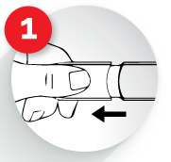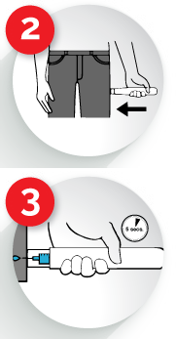REMOVE NEEDLE SHIELD

PRESS AGAINST THE OUTER THIGH

HOLD FOR 5 SECONDS
Massage the injection site gently, then call 999, ask for an ambulance stating “Anaphylaxis”


This is a medical document that can only be completed by the child’s healthcare professional. It must not be altered without their permission. This document provides medical authorisation for schools to administer a ‘spare’ back-up adrenaline autoinjector if needed, as permitted by the Human Medicines (Amendment) Regulations 2017. During travel, adrenaline auto-injector devices must be carried in hand-luggage or on the person, and NOT in the luggage hold.

I consent to the above
I
Date:

Additional instructions:
If wheezy, GIVE ADRENALINE FIRST,
then asthma reliever (blue puffer) via spacer

Photo

© The British Society for Allergy & Clinical Immunology 6/2018

